THE ROOTED LIFE

Colossians 2:7
‘…….continue to live your lives in him, rooted and built up in him…..’ from the Bible

Date: February/March 2023

A WBC MAGAZINE

Welcome to news from the Baptist family of Wymondham, Roots Community Café and the local community.

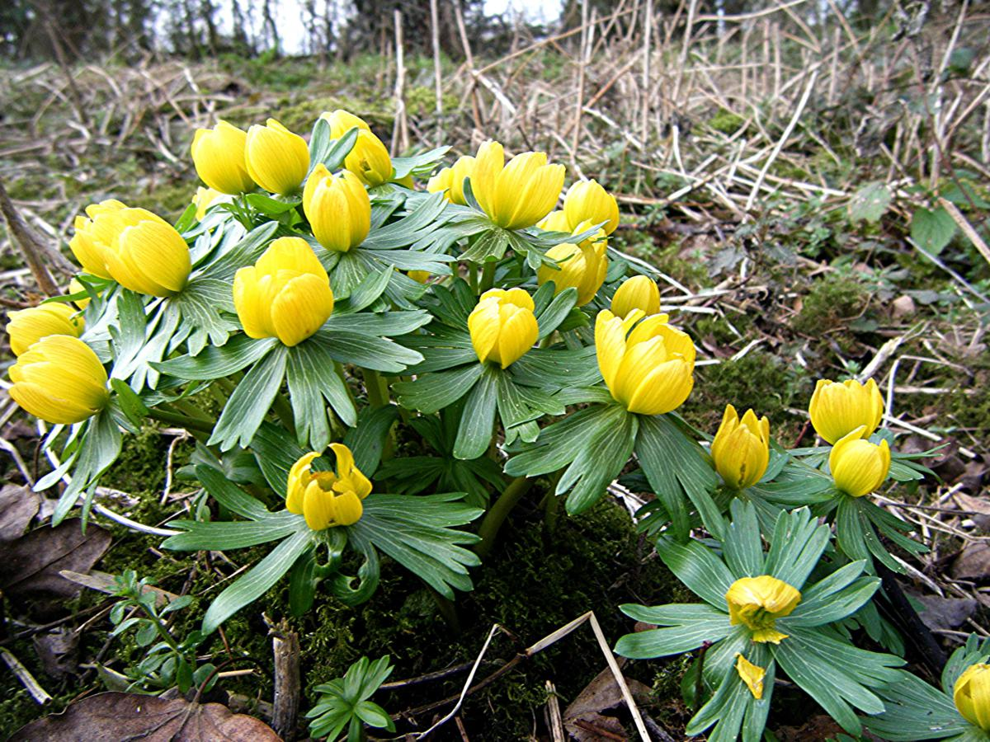

In this edition…

Spring is coming ……………………………………..

Welcome to the ninth edition of our bi-monthly magazine.

We hope that you found the earlier editions interesting, this issue has more items of interest contributed by a variety of different people - we hope there will be something of interest to everyone. If you would like to write something for our next magazine, please drop it in to Wymondham Baptist Church Office by Sunday, 26th March 2023.

In this edition we hope you enjoy the following…

Contents
- Message from our Pastor page 3
- A Word from Rosedales page 5
- Did you sort the words? Page 6
- A good book to read page 6
- Dates for February page 7
- Puzzle to work out page 7
- Dates for March page 8
- Test your word power page 8
- Spring Worship Walk page 9
- Connect with God’s creation over Lent page 9
- Love Wymondham, Love Earth page 11
- A picture to colour page 12
- ECO church news and Dates for the Diary page 13
- Recycling Update page 14
- Community Seed Swap page 15
- Windmill House Services page 16
- Photos taken at Paul’s Ordination page 16

A message from Paul Smith, our Pastor at WBC…..

Spring is just around the corner! It might not feel like it but it is. Soon we will be blessed with brighter days, more sunshine and hopefully less reliance on our heating, praise God.
But at times that can feel a long way off. It can feel that the darkness is overwhelming and although I know in my mind that we will see the light I, like so many I know, become impatient in the desire for its arrival.
It doesn’t help that sadly the world I see around us is also filled with darkness. As I write this there is news of two mass shootings in America, the invasion of the Ukraine is still on going and the inequality in the lives of people I know personally is still prevalent, be that in incomes, social care or disabilities. The darkness can seem as if it will never be defeated. What can we do?
At the beginning of January two things happened. One on a personal level and the other a memorial day. The later was that it was Martin Luther King day. It is a day to celebrate his life and legacy, which is observed on the third Monday of January each year, near his birthday which is January 15th.
Martin Luther King Jr. was a fellow Baptist minister and a civil rights leader who led nonviolent protests to help achieve equal rights for African Americans. He began to take a stand against the issues by organising non-violent protests and speaking publicly, his most famous speech being the "I Have a Dream" speech at the landmark March on Washington in 1963.
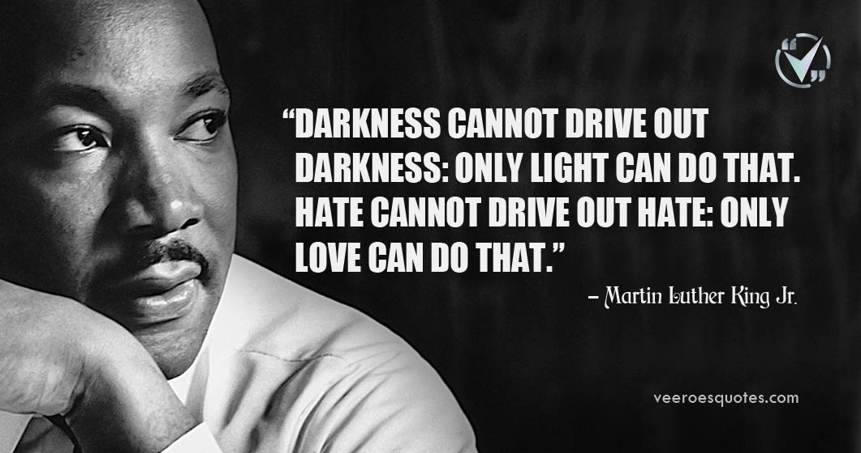
In 1964, he won the Nobel Peace Prize for combating racial inequality through non-violent resistance. Sadly, just four years later, he was assassinated in Memphis, Tennessee. He, for me is an inspiration, in standing against injustice. However, it isthe way he did it that has always inspired me. Here is one of my favourite quotes of his…..
Martin Luther King made a huge difference to the world around him and I find him both inspirational and challenging into thinking what do I do?
When I feel so utterly useless and helpless about the world around us and think what difference can I make I remember his quote. I cannot change the world but I can love those I come into contact with. I can be compassionate to people who may be different to me. I can bring light into people’s lives. I can be kind.
And that leads me on to my second thing that happened in January. I like many thought about making a new year’s resolution. I pondered many things I ‘should’ do, the usuals, exercise, read more, lose weight etc. however eventually after some time in prayer I decided on one. I made a resolution to ‘be kinder to myself’. Simple to say but hard to follow. It was like a light though in the darkness. If I want to be kinder to others, I need to first model kindness to myself. There are simple things I have started to practice. Taking a walk when I feel low, limiting viewing the news, and recognising I cannot do everything, but doing what I can do, and finally but most importantly praying more and handing over to Jesus the things that feel beyond me.
Jesus fully understands what it means to face a dark world. The Bible tells us all about his battle and victory over the evil in our world. In the gospel of John we are reminded that ‘the light shines in the darkness and the darkness has not overcome it’. This is what we will celebrate as Christians at Easter.
Jesus has victory over ALL darkness. Jesus also promised, as his followers, that we will be filled with His light and that by that we can have victory too over all things including the darkest of things, death.
As we head towards spring and indeed Easter, remember the light is coming. If you have never pondered what Jesus means in our world today and what having His light looks like perhaps you might want to explore that with us here at WBC. In the coming months we will be looking into starting an Alpha course which explains what we as Christians believe. We also look at how our faith comes into our daily lives in our worship services together every Sunday with teachings that are relevant to real life. You would be more than welcome to come along.
I pray for you all to know the light of the world HAS come, JESUS, and He is always here, there is no need to wait for the dark to pass the brighter days are already here! Perhaps we just need reminding.
Blessings
Paul

A WORD FROM ROSEDALES

Bereavement and trauma

A bereavement can make us feel like we are in shock, even if our loved one had been ill for some time and we knew their death was imminent.
We can still feel a sense of denial, that it hasn’t really happened and that they will be walking through the door at any time.
Being with our loved one in their final moments can leave us feeling traumatised as we recall how they looked or the sounds of their breathing.
If our loved one passed away suddenly, we may have tried to administer CPR in order to save them. The memories we are left with can be extremely traumatising.
We may feel the need to talk to everyone we know about the details of what happened- going over and over the events to try to make sense of what feels like a completely unreal experience. We may also struggle to sleep, as our thoughts torment us by continually re -running what happened.
Keeping a journal is a helpful way to process difficult and confusing thoughts and feelings. Writing down the story of your bereavement can help to process the reality of the loss and ‘download’ it from your mind. This can also be a good way to allow the tears to flow and grief to be expressed.
The senses exercise helps us to focus on the present: look around and list 5 things you can see, 4 things you can hear, 3 things you can touch, 2 things you can smell and 1 thing you can taste.
Mindfulness techniques and focussed breathing exercises can also help to calm the mind and body and bring us back to the here and now.
If you suspect you may be suffering from PTSD (post traumatic stress disorder), It is always best to seek specialist medical help, starting with your GP. Signs of PTSD include: experiencing vivid flashbacks, repetitive intrusive thoughts or images, nightmares, continually feeling on edge or experiencing physical symptoms such as shaking, sweating and feeling sick. If these signs continue and are having a significant impact on your life, then this it is important to seek help from a doctor.
In 2023, Rosedale will be running 3 bereavement groups in the church, starting on January 17th, May 9th and September 12th, led by Beverley and myself. If you would like to attend, please call 01953 601103.
Sarah (Rosedales)

Did you sort the Christmas words???

- TEHRAMEISCRST Christmas Tree
- DYCNCNAEA Candy Cane
- TTEIMLSEO Mistletoe
- LYIVOYLH Holy and Ivy
- SLEETIMOT Mistletoe
- LOCSRA Carols
- BEMDRECE December
- DRERENEI Reindeer
- SSJEU Jesus
- HDAAEERHP Shepherds

How many did you work out???

A GOOD BOOK TO READ –
A Single Thread by Tracy Chevalier –
This is a heart warming story of creativity, loneliness and community. It describes women after the loss of so many men, these women were called “surplus women”. Violet, lonely wanders into Wincchester Cathedral and finds the brderers, women who create beautifully embroiderd kneelers, still made today. A non embroider, she joins the group and learns the craft. The story unfolds gently, a mixture of loss, discovering friendship and the enjoyment of creating something lovely. I couldn’t read it fast enough but didn’t want to finish it. I loved it and thoroughly recommend it.
Claire Drake

Wymondham Baptist Church is now a Charitable Incorporated Organisation registered with the Charities Commission – Charity No. 1199302

If you would like to make a donation to Wymondham Baptist Church General Fund or to the Building Fund please make this to the following account:-
Sort Code – 30-90-89 Account Number 47748863

DATES FOR FEBRUARY:-

February 5th Worship at 10.30a.m. including Communion (bread used is GF)
February 6th Roots Community Café at WBC – 10.00a.m. – 1.00p.m.
February 6th Finance Team Meeting
February 7th Rosedales Bereavement Course – 10.00a.m.
February 7th Thrive@Roots – 2.30p.m.
February 8th Home from Home – 1.30p.m. – 4.30p.m.
February 9th Home from Home – 1.30p.m. – 4.30p.m.
February 10th Roots Community Café at WBC – 10.00a.m. – 1.00p.m.
February 10th Friday Night Youth – 6.30p.m.
February 12th Worship at 10.30a.m.
February 13th Roots Community Café at WBC – 10.00a.m. – 1.00p.m.
February 13th Leadership Team Meeting – 7.30p.m.
February 14th Rosedales Bereavement Course – 10.00a.m.
February 15th Home from Home – 1.30p.m. – 4.30p.m.
February 15th Eco Meeting at 3 Jackdaw Close – 7p.m.
February 16th Home from Home – 1.30p.m. – 4.30p.m.
February 17th Roots Community Café at WBC – 10.00a.m. – 1.00p.m.
February 19th All age Worship at 10.30a.m.
February 20th Roots Community Café at WBC – 10.00a.m. – 1.00p.m.
February 21st Rosedales Bereavement Course – 10.00a.m.
February 21st Thrive@Roots – 2.30p.m.
February 22nd Home from Home – 1.30p.m. – 4.30p.m.
February 23rd Home from Home – 1.30p.m. – 4.30p.m.
February 24th Roots Community Café at WBC – 10.00a.m. – 1.00p.m.
February 24th Friday Night Youth – 6.30p.m.
February 26th Worship at 10.30a.m.
February 27th Roots Community Café at WBC – 10.00a.m – 1.00p.m.
February 28th Rosedales Bereavement Course – 10.00a.m.
February 28th Thrive@Roots – 2.30p.m.

PUZZLE TO WORK OUT
If you know your ABCs, you should be able to solve this Bible puzzle. Remove each letter of the alphabet, in order. Then write the remaining letters in the blanks at the bottom to spell an important Bible verse.
J A E S B U S C A N S W D E R E D E, “I F A M
T H E G W A Y H A N I D T J H E K T R U L T H
M A N D N O T H E P L I Q F E. N O R O N S E
C O M E T S T O T U H E F A V T H E W R
E X C E X P T T H Y R O U G H Z M E.”
Answer:
__ __ __ __ __ __ __ __ __ __ __ __ __, “ __ __ __
__ __ __ __ __ __ __ __ __ __ __ __ __ __ __ __ __
__ __ __ __ __ __ __ __ __ __ . __ __ __ __ __
__ __ __ __ __ __ __ __ __ __ __ __ __ __ __ __
__ __ __ __ __ __ __ __ __ __ __ __ __ __ __.”
Do you know where this verse is found? ________

DATES FOR MARCH –

March 1st Rosedales Monthly Bereavement Group – 10.00a.m.
March 1st Home from Home – 1.30p.m. – 4.30p.m.
March 2nd Home from Home – 1.30p.m. – 4.30p.m.
March 3rd Roots Community Café at WBC – 10.00a.m. – 1.00p.m.
March 5th Worship at 10.30a.m. including Communion (bread is GF)
March 6th Roots Community Café at WBC – 10.00a.m. – 1.00p.m.
March 6th Finance Team Meeting
March 7th Rosedales Bereavement Course – 10.00a.m.
March 7th Thrive@Roots – 2.30p.m.
March 8th Home from Home – 1.30p.m. – 4.30p.m.
March 9th Home from Home – 1.30p.m. – 4.30p.m.
March 10th Roots Community Café at WBC – 10.00a.m. – 1.00p.m.
March 10th Friday Night Youth – 6.30p.m.
March 12th Worship at 10.30a.m.
March 13th Roots Community Café at WBC – 10.00a.m. – 1.00p.
March 13th Leadership Team Meeting – 7.30p.m.
March 14th Thrive@Roots – 2.30p.m.
March 15th Home from Home – 1.30p.m. – 4.30p.m.
March 16th Home from Home – 1.30p.m. – 4.30p.m.
March 17th Roots Community Café at WBC – 10.00a.m. – 1.00p.m.
March 19th Café Church at 10.30a.m.
March 20th Roots Community Café at WBC – 10.00a.m. – 1.00p.m.
March 21st Thrive@Roots – 2.30p.m.
March 22nd Home from Home – 1.30p.m. – 4.30p.m.
March 23rd Home from Home – 1.30p.m. – 4.30p.m.
March 24th Roots Community Café at WBC – 10.00a.m. – 1.00p.m.
March 24th Friday Night Youth – 6.30p.m.
March 26th Worship at 10.30a.m.
March 26th Church AGM – 12.30p.m./Election of Leadership Team
March 27th Roots Community Café at WBC – 10.00a.m – 1.00p.m.
March 28th Thrive@Roots – 2.30p. m.
March 29th Home from Home – 1.30p.m. – 4.30p.m.
March 30th Home from Home – 1.30p.m. – 4.30p.m.
March 31st Roots Community Café at WBC – 10.00a.m. – 1.00p.m.

TEST YOUR WORD POWER!!

How many words can you make out of Ecclesiastes?

And how many can you make out of Deuteronomy?

Save the date!
Spring Worship Walk
Sunday 30th April
Come and join us for a spring walk in Ashwellthorpe woods. We will be leaving WBC at 3pm and returning about 5pm. It will be a time to look, hear and reflect on God’s creation at this lovely time of year, either with friends and family or quietly by yourself.
More details will follow but please put the date in your diaries. It should be a lovely time of outdoor fellowship.

Connect with God’s creation over Lent
As we begin the season of Lent in February, let us pray that God will open our eyes each day to see something new and wonderful in His world, so we may choose to be more considerate towards your creation during this time of reflection and beyond
Week One - Bring nature into your home or garden. What could you grow
inside your home, in the garden or even at church? Plant a herb or flower as a
reminder of our responsibility to steward God’s earth. As you tend to this plant,
prayerfully ask God how you might nurture nature better at home over the Lent
period and beyond.
Week Two - Connect with creation in a new way. Time spent enjoying God’s
creation will help set your mind and seek the things that are above. Bring
your sketch or note book, your Bible, or whatever helps you connect with our
heavenly Father. Or perhaps God is inviting you to just bring yourself (with some
extra layers!). Note all the signs of the season. Use this time to reflect on the changing season and what we can be thankful for.

Week Three - Discover the great outdoors with company. Meet up with a friend
or several for an extended or brisk wintery walk together. You could visit an
outstanding area of beauty in the UK or keep it local and soak up the seasonal
sights on your doorstep in your nearest green space. Bring along a notepad and
pens to write about or draw something that inspires you in nature and share
your ideas and reflections.

Week Four - Plan a Wild Time! Plan something completely wild in nature for
later this year. Experience kayaking, wild camping, forest school, forest church...
Make sure to take the opportunity to really enjoy what nature has to offer
beyond Lent. Break out of your normal routine and join a volunteer work party
or take to the water for wild swimming. Whatever you do – do something
different and have fun!

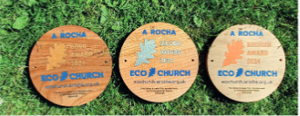
Week Five - Join us to protect and restore nature together. How can we make
small changes in our everyday lives that can make a big difference to others
and for your world? Contribute to positive change as part of an A Rocha UK
community, as a church (Eco Church) and as an individual or family (Wild
Christian).

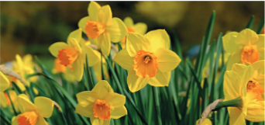
Week Six - Be still in nature. During Holy Week, find a quiet spot outdoors
and reflect on what Holy Week means to you. Surrounded by the beauty and
creativity of nature, the shortcomings of humanity and our need for repentance
are often clearer, but so also is the power and timelessness of God. Bring before
him your own concerns and the needs of the natural world. Continue to pray
with us via our weekly prayer diary at: arocha.org.uk/get-involved/pray.
Easter Sunday - The Easter hope of reconciliation is good news for all. May we
celebrate anew Christ’s commitment in relating to his creation; that the God-
man Jesus would enter into the deepest pains and realities of the flesh in order
to restore the relationship between Creator and creature. By this restorative
work all creation is reconciled to its intended delight, finding peace and mutual
flourishing.
From A Rocha resources

Love Wymondham Love Earth
By Ian Maunders, Greening Wymondham
For those who enjoy the outdoors, Wymondham has a lot to offer as you take your daily exercise: a peaceful stroll through the town to the Abbey, where you can experience beautiful sunsets, a meander across the nature reserve at Toll’s Meadow or a walk down the Lizard. Maybe visit Kett’s Park Wood, where Greening Wymondham volunteers are continuing to improve the area, creating glades to encourage wildflowers and a more diverse habitat for wildlife.
Valentine’s Day is approaching and in nature, romance is in the air, judging by the birdsong and activity in the trees and hedges along the roadside and in parks and gardens. Also in the garden, the promise of Spring is beginning to show as bulbs push up their shoots and buds appear on the trees and bushes. These are the same trees and plants that Earth needs to help it to sustain life, so don’t just love Wymondham, love our planet. It is the only one we’ve got and now it needs all the love we can give it to keep it healthy, for life as we know it to continue.
So, just for a while, consider the effects of your actions; think what you can do to help. Relax and concentrate on the simple pleasures in life; you’ll feel better for it and so will those you love.

A PICTURE TO COLOUR

ECO CHURCH NEWS AND DATES FOR THE DIARY
Raised vegetable bed for the church garden:
This is going ahead, and Keith has kindly researched the materials and costings and has agreed to build it for us. It will be ready for vegetable and salad planting in the spring. We are looking for someone to look after the veg bed once it is planted so, please see Cathy if this is something you would enjoy doing.

Bird boxes:
Last year the young people built and located 3 bird boxes in the church garden. If anyone is in the garden and notices activity in and around any of the boxes, please could you take a photo and let us know?

Saturday 4th March: Community Seed Swap event
The Eco team are excited to be organising this event as another way to demonstrate our care for creation by encouraging the sharing of resources. We also hope that it will be a great opportunity for experienced, new and would be growers to get together and share tips, ideas and plans for how to look after our outdoor spaces. Bring along your spare plant and vegetable seeds to swap and enjoy a chat over a cup of tea or coffee and cake. All proceeds will go to Eco Church projects. A poster with all the details is on the Eco Church board in church.

Friday 24th February from 6.30-8.30pm at Central Hall: Climate Change is here…..What now?
This has been organised by CHAIN (Climate Hope Action in Norfolk) and is a public meeting with a cross party panel including our MP George Freeman and representatives from the Labour, Liberal Democrat and Green parties. It will be an opportunity to hear how each party aims to meet the challenges of the climate crisis. This is a free event but is on a first come, first served basis. Full details are on the poster below and on the Eco Church noticeboard in church.

RECYCLING UPDATE

BLISTER PACK COLLECTION
Unfortunately, we can no longer collect your empty blister packs. I took a few bags into Norwich a couple of weeks ago and spoke to the pharmacist there who asked me if all the bags were from my own personal use. She explained that Superdrug have a strict policy that customers can only take in their own personal empty blister packs and not drop off those belonging to friends. This is so disappointing as it has been a very popular recycling opportunity for us meantime, if you are going into Norwich, you can still drop off your own blister packs at Superdrug. Nicki

EXISTING RECYCLING OPPORTUNITIES
We are still collecting your used toothpaste tubes, toothbrushes and electric toothbrush heads. Please put them in the marked bag in the corridor opposite the kitchen door.
We would also love all your old pens etc. These go to Rymans in Norwich and Ruth Rallan is happy to do this on her visits to the city. Rymans are glad of as much old stationery items as we can take. A list of the items that are accepted is on the Recycling board in the corridor. Thank you, Ruth!

NEW RECYCLING OPPORTUNITIES
We are now collecting your empty crisp and nut packets, coffee packets and dishwasher and washing machine tablets bags.
Examples of what we are collecting is on the recycling board with a couple of requests.
Please give your empty crisp and nut packets to Rose Kirby who has kindly agreed to sort them out.
Please put your empty coffee packets and dishwasher/washing machine tablet bags in the marked bag in the corridor.
These, together with the toothbrushes and toothpaste tubes are taken to Val Keel in Wreningham who recycles them via Terracycle and raises money for charity.
Thank you for your help and support in keeping plastic out of landfill.
The Eco Church Team

Community Seed Swap
Wymondham Baptist Church
Saturday 4th March
10.30am -1.00pm

Are you planning your summer garden? Have you got a surplus of seeds?

Would you like to try growing something different from seed?
Yes? Then……….
Bring along all your excess seeds and swap them for something different.
Enjoy sharing and swapping tips and suggestions with other growers over a cup of coffee and cake.

(No charge for the seeds and refreshments by donation. All proceeds to Wymondham Baptist church Eco Church projects)

WINDMILL HOUSE SERVICES
We had been looking forward to being at Windmill House in December to hold our first live Carol Service since before the pandemic. We had made all our preparations - carols and readings chosen , talk prepared , musician lined up .
Then everything had to change as Doug and I had covid! We were disappointed that we had to revert to leading a service on zoom, from our living room, with just the two of us. It's just not the same as being face-to-face but we were glad we could still provide a service for the residents.

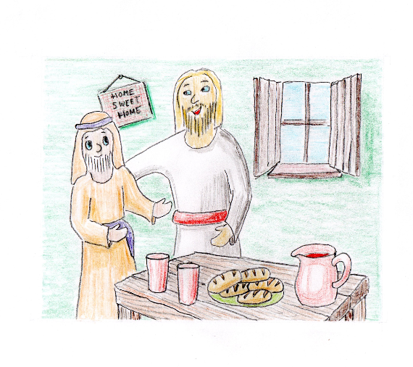
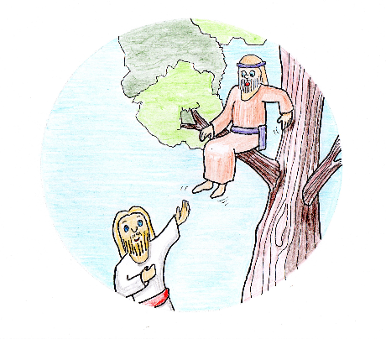
In January we were at Windmill House and able to mingle with the residents without wearing masks for the first time . As always we received a very warm welcome . Vic was unable to be there but Doug , Mary and I were joined by Christine Frith who has worshipped at WBC since moving to Wymondham . We sang familiar hymns together with some of the residents joining in enthusiastically, then looked at the story of Zacchaeus and how Jesus transformed his life, accompanied by Vic's pictures of Jesus looking up at Zacchaeus in the tree and Jesus visiting Zacchaeus at his home.

We now have dates booked for March and May with Steve Cullis, the Methodist Minister taking services in February, during Holy Week in April then early May before he goes on sabbatical during the summer. We'll be looking at how we can cover the months he is not available.

We are grateful to those who pray for us as we go to share this time with residents who are no longer able to attend a place of worship.

Jan Hodges

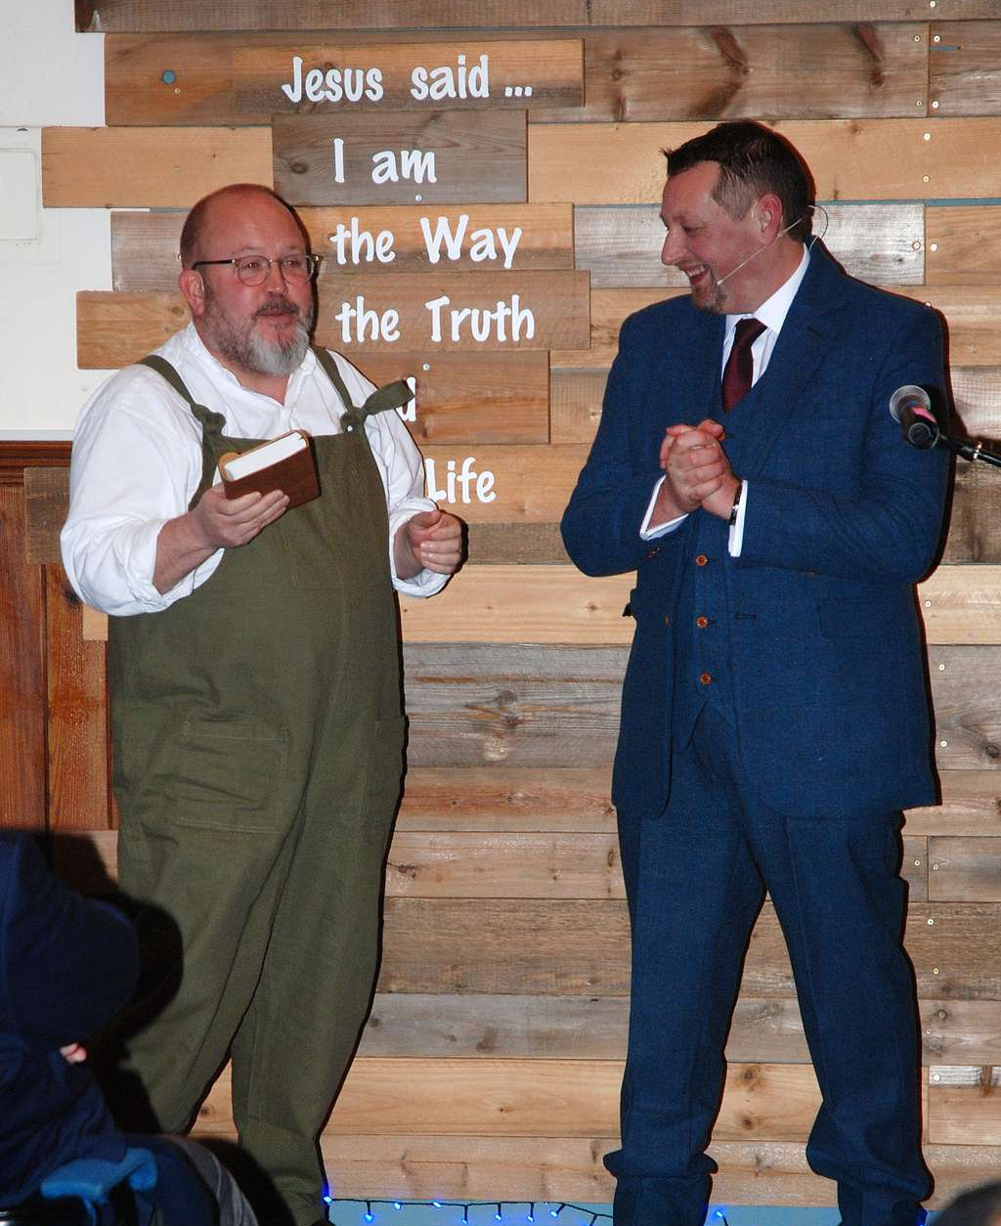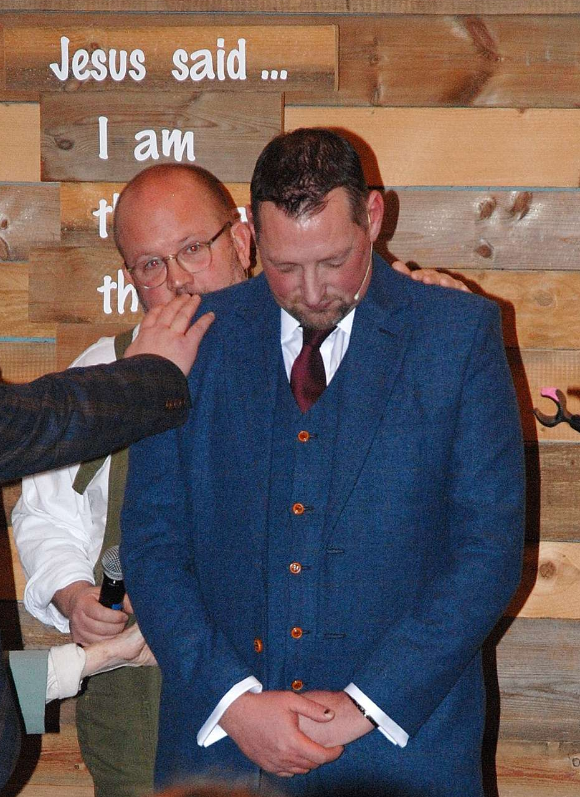
Photos taken at Paul’s Ordination

