THE ROOTED LIFE
Colossians 2:7
‘…….continue to live your lives in him, rooted and built up in him…..’ from the Bible

Date: June 2022

A WBC MAGAZINE

Welcome to news from the Baptist family of Wymondham, Roots Community Café and the local community.

In this edition…

Jubilee celebrations, what can you remember of the last 70 years?????

Welcome to the fifth edition of our new bi-monthly magazine.

We hope that you found the earlier editions interesting, this issue has more items of interest contributed by a variety of different people - we hope there will be something of interest to everyone. If you would like to write something for our next magazine, please drop it in to Wymondham Baptist Church Office.

In this edition we hope you enjoy the following…

Contents
- Message from our Pastor page 3
- 1952 – 2023 page 4
- A Word from Rosedales page 6
- Cryptic Song Titles Quiz page 7
- A picture to colour page 8
- June/July dates page 8
- Do you need a bag page 9
- Don’t waste bread!! page 10
- Recycle, recycle, recycle page 11
- Graduation celebrations page 12
- Getting your car ready for summer page 13
- Windmill House Ministry page 14
- Hedgehogs and other visitors page 15
- A visit to Oberammergau page 16

Further information about Wymondham Baptist Church or to contribute to our magazine please contact the office – office@wymondhambaptist.org or ring 01953606520 or check out website – www.wymondhambaptist.org

A message from Paul Smith, our Pastor at WBC…..

Thank you for reading this latest edition of Rooted Life. I really hope you enjoy it. If you have any ideas of content you would like to see or indeed if you would be happy to write an article we would be delighted to hear from you.

Can you believe that we are already half way through the year!! Where does time go? No doubt the Queen has probably reflected on that over the past few weeks.

We, as a church, spent time praying and giving thanks for the Queen’s service and care for our nation. She has led this nation with integrity and loyalty. By her own admission she has done this with the nation’s support, love and prayers. Queen Elizabeth has a strong personal faith and refers to it often. Later in this edition you will ready my own reflections on how I feel carried along by other’s support and my own faith.

I managed to see some of the Jubilee celebrations on the TV. What wonderful images there were. It was so good to see the light shows, the musical celebrations and how great was it to see the young royals, they really made me smile. It showed that, overall for all intent and purpose the Royals are just ordinary people carrying out an extraordinary role. It is reassuring to know that her majesty trusts and relies on our extraordinary God. With all you have to carry out in life, who do you rely on to help you?

The God who the Queen relies on is the same God you can know, and He sees all people as the same – that is something worth celebrating.

Blessings

Paul

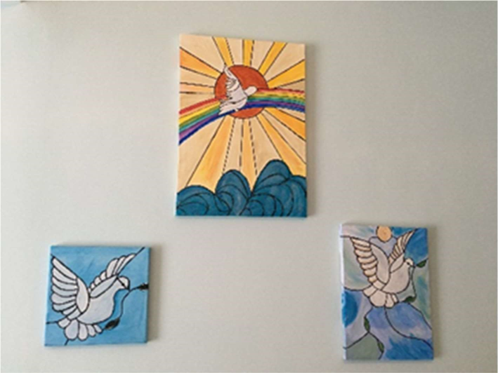

Beautiful picture painted by Jeanette Ellse

1952 – 2022

Photograph of a street party from Ann Flaxman

Memories from Susie Morrish

I was eight when the Queen was crowned. I lived with my mum and dad being the eldest of four children, in Lound Road Norwich, it was known as the square because of its shape. 28 houses round the outside of a green area which was closed off to wrought iron railings and a large double gate to enter so no kids allowed.

All the mums and some dads helped and each family made decorations with crimped paper like Christmas decorations. the children, including myself with adult help weaved the trimmings though the railings finished off with lots of balloons all tied on to the railings. It was so exciting as we were going to have a street party. There were and still are 28 houses in Lound Road, (semis) and around 15 to 20 children at that time.

The mums made cakes and gave jars of homemade jam.

On the following day it was windy and wet.

My mum had an idea and went to the Volunteer pub on Earlham Road and asked for help. (It was my dad’s local). The landlord offered a room to accommodate the party, so all of us and the mums and dads walked 15 minutes to the venue, arrived feeling wet and chilly but it didn’t stop us kids from Lound Road enjoying the party of jam sandwiches cakes and jelly! Not forgetting lots of Corona to drink!

Memories from Kathleen Garlish

After the coronation of Her Majesty Queen Elizabeth II, she visited the town in which I lived and went to school, which was Rickmansworth in Hertfordshire.

I remember standing with other pupils and our teachers outside our school gates. Awaiting her Majesty’s arrival we were excited. When the time came, her car was driven very slowly passed us so we were able to see the Queen clearly. A very special day.

Memories from Cathy Finch

My memories are very sketchy as I was quite young. I do remember however having a street party and having flags to wave. I think I started school just before the coronation and there were red, white and blue flags everywhere. We didn’t have a television until a few years later, so I seem to think that we watched it on a neighbour’s television and listened on the radio. I remember making a scrapbook of newspaper cuttings – we can’t find it now, but the newspapers were full of every aspect of the coronation and the queen and the royal family for days. Maybe even weeks.

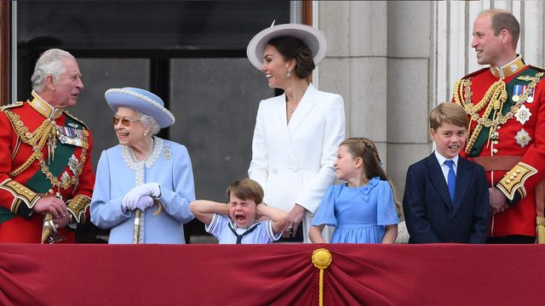

A WORD FROM ROSEDALES

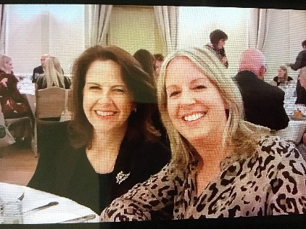

A few weeks ago it was UK Mental Health Awareness Week. This year’s theme was Loneliness.
Loneliness can be experienced by anyone at any point in life. We can be married, have friends and family yet still feel lonely. We can be ‘lonely in a crowd’ but equally we can be alone yet not feel lonely. Although I have a family, I regularly spend time alone as this is how I recharge my batteries. If I don’t have this time, I become quite stressed and grouchy!
Loneliness carries a stigma and it is often hard to admit how we feel. However, no one is immune from feeling lonely, it is part of the human condition.
Mother Theresa had a lot to say about loneliness: “There is much suffering in the world……..but the greatest suffering is being lonely”.
“There are many in the world who are dying for a piece of bread, but there are many more dying for a little love.”
She called loneliness ‘The leprosy of the west.’
As part of Rosedale’s Bereavement Support Course, we explore how grief, loneliness and isolation are linked and often experienced by those who are bereaved. When we are grieving, it is tempting to want to withdraw from others. This may be helpful for a time as we allow our grief to flow. However, connecting with others is one way to help with loneliness. Of course, we may still be lonely for the person and relationship that has been lost and people cannot be replaced, but connecting, caring and helping others can bring a sense of fulfilment which can lessen feelings of loneliness.
It is always a joy for Beverley and myself to witness how our bereavement group participants form friendships, care for and support one other.
Mother Theresa believed that the only cure for loneliness, despair and hopelessness is love.
She also said “It is easy to love the people far away. It is not always easy to love those close to us……in our own home. Bring love into your home for this is where our love for each other must start.
Sometimes we can take our frustrations out on those closest to us or take them for granted.
Even if we live alone, we can still love those around us. Simple acts such as chatting to the person behind the counter when we are out shopping, talking to someone at the bus stop, smiling at someone in the street, inviting a next- door neighbour round for coffee. There are also many local groups or volunteering opportunities to get involved in.
All these forms of human connection can help to alleviate someone else’s loneliness and help us feel a little less lonely too.

Cryptic Song Titles Quiz
- There is not an ounce of truth in this (4 words)
- Low-cost thoroughfare (2 words)
- Policeman’s young lady (2 words)
- Celestial small change (3 words)
- Statement of perfect health (3 words)
- Exhibition in North Yorkshire (2 words)
- Golden state babes (2 words)
- An unspecified location (1 word)
- Pre-owned flower (3 words)
- Lancashire girl who takes the cake (2 words)
- An enquiry as to breakfast preferences (9 words)
- Beaufort scale 10 (2 words)
- Granite tea room (3 words)
- Unearned income (3 words)
- Rio beach or New York nightclub (1 word)
- Sixty percent of a royal flush (6 words)
- Hours of darkness during June – August (2 words)
- Bring on precipitation in triplicate (6 words)
- Song by Martin Luther King JR (4 words)
- 100% or zero (3 words)

Answers will appear in our next issue…..

A picture to colour …………….
JUNE/JULY DATES TO REMEMBER
June 11th – ECO@WBC – 10.00a.m. – 1.00p.m. July 3rd – Worship at 10.30a.m.
June 12th – Worship at 10.30a.m. July 4th – Finance Team Meeting
June 13th – Leadership Team Meeting July 6th – Rosedale Monthly meeting
June 14th – Rosedale Bereavement Course July 8th – Friday Night Youth
June 17th – Quiz Night sponsored by Rosedale – 7.00p.m. July 10th – Worship at 10.30a.m.
June 19th – Fathers’ Day Worship at 10.30a.m. July 11th – Leadership Team Meeting
June 21st – Rosedale Bereavement Course July 17th – Mission – Falconer Trust
June 24th – Friday Night Youth July 17th – Church Meeting – Election
June 25th – Closing date for nominations for Diaconate of deacons
June 26th – Café Church July 22nd – Friday Night Youth
June 28th – Rosedale Bereavement Course July 24th – worship at 10.30a.m.
July 31st – Worship at 10.30a.m.

Roots Café is open each Monday and Friday – 10.00a.m. – 1.00p.m.
Thrive@Roots is open each Tuesday in term time – 2.30p.m. – 4.00p.m.

Do you need a bag?
By Nicola Maunders, Greening Wymondham
Most of us take our own bags when we go shopping now but we all get caught out without one now and again. What is best for the environment, paper or plastic? What about cotton?
Papermaking involves extraction of a raw material from trees. It is a resource-heavy process which uses a lot of energy and large amounts of water and chemicals. The live-cycle analysis of paper shows it has a high carbon footprint. Processing involves the emission of toxic chemicals into the air and water pollution. Paper bags are heavier than plastic so use more trucks in transportation causing more air pollution and carbon emissions. On the plus side, they biodegrade and do not accumulate in the environment. They are easy to recycle and are sometimes used to make more paper bags.
Plastic also involves extraction of a raw material. This time it’s from oil. It is also resource-heavy, but processing involves less carbon emissions, less water and less chemicals. It is stronger than paper so can be re-used more often. However, plastic can block drains, alter ocean habitats and damage wildlife. It does not biodegrade but breaks up into tiny particles eventually and stays around for hundreds of years. Particles of plastic have been found in human tissue.
What about cotton bags? Cotton has the highest carbon footprint of all due to the high water and pesticide use in its production. A cotton bag would need to be used 131 times to have the same carbon footprint as a plastic bag. This is reduced if organic cotton is used.
So, which bag should I choose to use? The best type of bag is the one you take with you, a durable reusable bag that you can use time and time again. This reduces your environmental impact. If you have forgotten your bag, consider carbon emissions, water usage, pesticide usage, effects on wildlife and what will happen to your bag when you have used it. Whatever you choose, please recycle where possible but don’t forget, recycling is a last resort after you have considered the Rs: Refuse, Reduce, Reuse, Repurpose, Recycle.

Don’t waste bread!
If your favourite loaf is starting to go dry, don’t fret about throwing it away. Here are a few tips for making sure that no bread ever goes to waste:
Keep sliced bread in the freezer until you need it

Refresh your stale loaves by putting them in the oven for a few minutes, and they will soon get that
freshly -baked taste

Don’t buy breadcrumbs. Process any slices that are too dry to eat, and keep them in a jar for future
recipes.

Make homemade croutons. All you need to do is slice your bread into cubes and lightly bake them in
a drizzle of melted butter, crushed garlic and the favourite recipes

French toast. Any slices that are just a little too dry to enjoy as part of a sandwich are still perfect for
for this delicious breakfast

Garlic bread. This is a great way to use up stale baguettes.

Stuffing……doesn’t just have to be for Christmas!!

Recycle, recycle, recycle!!
I was recently talking with Penelope who gave me a startling fact …..if King Henry VIII (he was born in 1491) had worn disposable nappies, they would still be in the ground and would not have decomposed!
So how can we stop our waste, particularly plastic waste going to landfill? Be encouraged!! There are more and more opportunities for recycling and here are just a few:
The Co-op on the Market Cross has a small recycling bin for soft plastics, crisp and cheese wrappers and some biscuit and sweet wrappers.
Morrisons now has a large bin just outside the entrance for the same. Many of Morrisons packaging now has a label to say that it can be ‘recycled with bags at larger stores’.

New recycling opportunities at WBC
We now have a dedicated ‘Recycling Station’ at WBC to enable us to recycle items that cannot currently be recycled in our green bins.
In addition to the used stationery that we already collect, we are now encouraging you to bring in the following for recycling:
- Empty toothpaste tubes and toothbrushes, including the brush part of electric toothbrushes.
- Medical blister packs. (e.g. for paracetamol)
The Recycling Station is found in the corridor, opposite the kitchen door. Please make sure items are clean and dry before placing them in the appropriate bag. Thank you in advance for your support with this project!

What will happen to above items?
The used stationery is collected regularly by Sam Rallan and taken to Wreningham Primary School where it is recycled via the company Terracycle.
The toothpaste, toothbrushes and blister packs will be collected by Nicki and taken to Val Keen in Wreningham who then sorts the items and sends them to Terracycle.
What is Terracycle?
Val Keen will be at our ECO@WBC event with a display about her recycling work and Terracycle, so why not come along and find out more? ( ECO@WBC is on the 11th June from 10.00-1.00)

If you know of any other opportunities for recycling and to reduce putting waste to landfill, we would love to hear about it so that we share it with others in our church fellowship and wider community. Please give Nicki or Cathy the details.

Graduation celebrations

Just recently I took part in my graduation service celebrating my completion of a degree in Theology, Mission and Evangelism, which I studied with the Light College under the umbrella of the University of Chester. I spent three years in study which meant some time away either in Chester or Birmingham on ‘learning’ weekends, followed by distance study and then various different assignments. I thoroughly enjoyed the teaching and the reading that we were set.

Having last undertaken any form of study in my teens it was a strange experience returning to Uni in my late forties! I was unsure at times if I had the abilities or the stamina to see it through.

The graduation service itself was held at Chester cathedral and was such a fascinating event. It is miles away, not just in location, but also miles away from anything I am used to. For instance, there was a lot of robes, trinkets and official proceedings. I am more used to an apron, perhaps a watch and am very relaxed in my approach to most things. However, I really enjoyed the occasion. As part of the service, which included the presentation of awards to over 200 other students, there was an honorary doctorate given to Baroness Floella Benjamin. For those of you who are old enough you may remember her as I do from her days on the children’s tv program Playschool. I was familiar with seeing her through the round window, but not in the pulpit. She made a very good and impassioned speech, highlighting overcoming difficulties and adversity. As I pondered what she was saying I reflected on my own life. I left school at the age of 16 and was often told as a youngster that I wouldn’t ‘amount’ to much. Well, I still wouldn’t say I have! But I did feel a sense of achievement as I sat in the cathedral alongside my friends and peers. I also felt a real sense of belonging.
I want to encourage you that it is never too late to go and do something new! Perhaps you too are being held back by doubts, thoughts hanging over you from way back….well if I can do it so can you!

A closing thought…. The award I was given was not mine alone. We live in a world that constantly promotes being an individual, when what we need more than ever is community. Though I was receiving my graduation awards alone I was only able to do so with the love and support of family, friends, my faith and the fellowship of the people here at WBC that helped spur me on. Their encouragement means as I received my degree it’s their achievement too.
I hope you find community here at WBC to love, support and nurture you as well.

Paul Smith

SPONSORED BY ROSEDALE – FRIDAY JUNE 7TH
TICKETS ARE £5 EACH AND ARE AVAILABLE FROM ROSEDALE AND THE CHURCH OFFICE – ALL PROCEEDS TO WYMONDHAM BAPTIST CHURCH BUILDING FUND.

Getting your car ready for Summer:

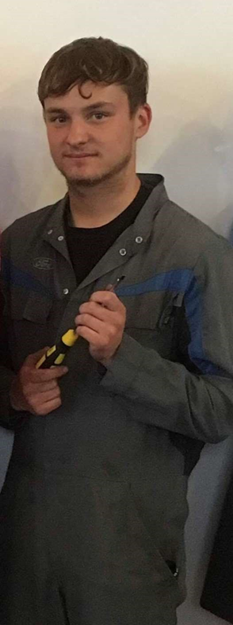
Check your fluid levels!
Oil level- As always you should check your engine oil level and make sure its topped up between the min and max mark on the dipstick. Keeping on top of your oil level and oil changes is important to protect and increase the longevity of your engine.

Coolant/antifreeze- Checking your coolant level is another important thing to do all year round, coolant is used to keep the engine at optimum temperature and stops it from overheating. It's very important that you keep an eye on your coolant level and quality during the summer. If you have a coolant leak or engine damage that causes a loss of coolant your engine will not be able to regulate temperature and overheat causing further damage to your engine and in some cases can cause a fire.

Washer Fluid- Check your washer fluid is topped up and filled with good quality fluid. This is important to rid your windscreen of those summer bugs that hit your windscreen when driving, good screen wash will have additives and detergents designed to breakdown and rid of bugs and dirt.

Other tips!
Check your A/C. When the summer heat hits, the cabin of your car will get very warm and uncomfortable. Turning on your interior fans will only recirculate the warm outside air around the car and not cool the cabin temperature. With your A/C turned on you should feel ice cold air coming from your vents. If this is not the case you may consider getting your system Re-gassed by a garage where they will also carry out a leak check on the system.

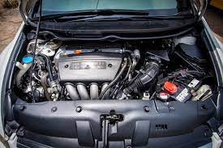
Tyre checks- The tyres are the most important part on your car to reduce loss of control. Checking your tyre pressures and tread depth is important to ensure your tyres are legal and safe. During the summer your tyres will be hotter which should help with grip but also puts extra stress on the tyre itself. Where grip is easier to find in the summer, increasing your tyre pressures can help to get back a few MPG that you will lose when driving with A/C on or windows down.

If all this seems a bit much for you then don’t worry, many garages offer a ‘Summer Check’ where they will check the things listed above any many more including, general condition of the vehicle, battery condition, brakes and more.

Owen Smith

Windmill House Ministry

On Wednesday 25th May, Mary,Vic, Doug and I were able to go in to Windmill House Care Home to lead a short worship service for the first time in more than 2 years. Christine was unable to join us but we hope to have a full team in July. Wymondham Methodist Church are responsible for alternate months. The last time we were able to visit in person was February 2020, just before Care Homes, Churches and all community groups and venues had to close their doors as the first lockdown was announced. Care Homes were very cut off from the outside world and they were hit hard by the pandemic but little information was available due to data protection.

Since May last year every 2 months we have 'met' with the residents on zoom - not the same as being together in the same place but still an opportunity to share in worship. We sang old familiar hymns to recorded music and the services followed the same pattern as live services would have done with prayer, bible readings and a short talk and the addition of pictures drawn by Vic to illustrate the talk. Harvest and a Carol service were highlights that were very well received and enjoyed by all. It was a good to be able to make use of zoom and we were glad we could minister to and encourage our friends at Windmill House.

Many of the residents are living with dementia and others are physically frail but until the Covid pandemic they had enjoyed going out into the community or welcoming individuals or groups into their home. A group of residents accompanied by family members, volunteers and staff would regularly go to the monthly Singing Cafe at Wymondham Dementia Support Group so I would see familiar faces in both places. All that social contact was greatly missed.
We had been looking forward to going back in for the first time but could only confirm that we could do so 2 days before. It was a joy to be back there and we were made very welcome. A good number of residents were gathered in the lounge supported by a few staff, but after so long we only recognised a few of them. We could lead the service at a distance without wearing masks and we sang to live music led by Vic and Mary. We needed masks in the lounge and I went and spoke to a few of the residents after the service. One lady was a real encouragement to us as she joined in the hymns enthusiastically and was singing 'What a Friend we have in Jesus' with her neighbour after the service, from the songsheets we had provided.

We hope to be back in Windmill House again on Wednesday 27th July then Wednesday 28th September. Please pray that we continue to be a blessing and an encouragement to those who live and work there.

Jan Hodges.

Hedgehogs and other visitors

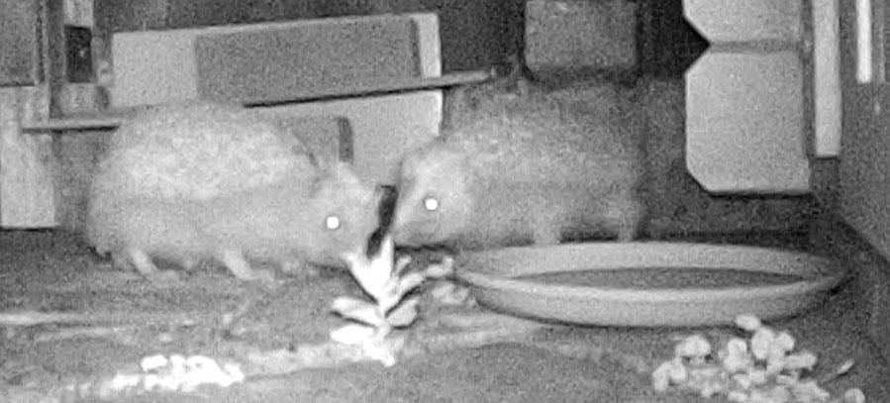

Towards the end of March we decided it was time to start feeding and filming the hedgehogs again as they would be out looking for food now the nights were less cold.

We started with small amounts of food until we knew how much activity there would be, but soon had to increase the amount to meet demand. All night long they were coming and going feeding and drinking. Individuals are not easy to identify so we are not sure how many we were seeing - definitely 2 possibly 3. Sometimes 2 hedgehogs jostle for space to get at food in the covered area we made, they might manage to squeeze in together or one might be determined to keep the second one out.

There were other visitors too - agile little field mice entertained us as two bright eyes appeared over a wall or through the slots in the bricks forming the feeding area. They would dash in, grab a whole piece of hedgehog food and disappear into the night briefly before returning for more.

Unfortunately when we attract wild life to our gardens we also get less welcome visitors - in broad daylight a rat came on the scene, sometimes just passing through, then coming to drink water left out for the hedgehogs. We were already careful to remove or cover any food left in the morning. After a few days we put out a trap baited with peanut butter and other traps but the rat avoided them. Some of our neighbours had seen 2 rats and called the rat catcher and other neighbours put down rat poison. We had already had to stop feeding the hedgehogs.

After about 3 weeks when there had been no sign of rats we started feeding again and the hedgehogs came straight back. We often see 2 at a time, sometimes pushing and shoving each nose to nose, behaviour we had not seen before. All the food we put out each night is eaten so numbers have probably increased to 3 or 4. Now we are hoping the adults may have produced young as we would love to see hoglets.

The other welcome visitors are a range of garden birds - we don't see anything unusual but enjoy the common varieties.

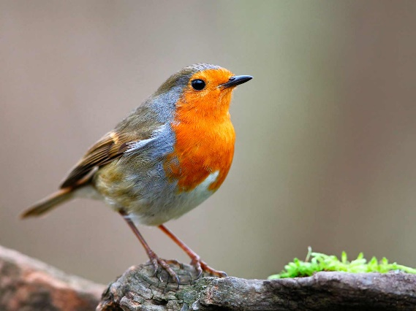
I'm charmed by the goldfinches, love hearing blackbirds singing, enjoy the chatter of sparrows; starlings appear in little flocks digging in the grass for insects, their plumage iridescent in sunlight, then take off together at the slightest sound or movement; robin sits on the fence watching with beady eyes or hops around looking for food; a pair of collared doves sit together on a branch; great tits and blue tits occasionally come to the feeders and of course the ubiquitous wood pigeon makes a bit of a messy nuisance of itself .
I gave up putting out fat balls, peanuts or mixed seed as for some reason they did not attract the birds and just went mouldy. Now sunflower hearts and suet pellets are the only foods I use and they are proving so attractive I have to keep buying more!

I get great pleasure from watching all the activity around the feeders and on the ground or just sitting outside with a cup of tea in the sunshine surrounded by birdsong. Then in the evenings there is video recording of our nocturnal visitors to watch. We don't need to go far to enjoy wild life. Now I just need to work on making the garden more attractive to bees and butterflies!

Jan Hodges

A visit to Oberammergau
Ray and I were very privileged to be able to take an exciting trip recently. We had planned to take a river cruise and attend the Passion Play at Oberammergau in 2020. Of course, due to the pandemic the trip was cancelled and as it is only performed every ten years we thought our opportunity to take the trip had passed. However, much to our delight it was re-scheduled for this year.
For those who don’t know the Oberammergau Passion Play is a very special play. It all started with a vow. In 1633, the plague was raging in Europe, including in the town of Oberammergau. People sought refuge in prayer and vowed: If the dying stops, every ten years we will stage the “play of the passion, death and resurrection of our Lord Jesus Christ. No one died of the plague from that day on. Since then, the people of Oberammergau have been performing the Passion of Jesus Christ every ten years. For 200 years, the play was staged on the cemetery near the church. However, as more and more people attended from all over the world the play was moved to the place where the Passion Theatre stands today.
Between the scenes theatrical depictions of old testament prophecies come alive as we realised anew the links with the new testament story. A massed choir and soloist provided an amazing contribution to the play.
The whole event was performed in German. Neither I or Ray speak or understand German, but somehow that didn’t matter. We were given an English translation which we could follow while it was daylight, but as the light faded this was not possible. We knew the story, but I think that even if we had not be familiar with the story, understand the words spoken did not seem necessary. The emotion and passion were amazing and we understood on a whole new level.
The whole experience was very memorable and well worth the wait.
Cathy Finch

