THE ROOTED LIFE

Colossians 2:7
‘…….continue to live your lives in him, rooted and built up in him…..’ from the Bible

Date - June/July 2025

A WBC MAGAZINE

Welcome to news from the Baptist family of Wymondham, Roots Community Café and the local community.



In this edition… What does the summer hold in store??

This magazine is brought to you by Wymondham Baptist Church. If you would like to know more about us, please call, e-mail us or visit our website.
Address: Queen Street, Wymondham NR18 0AY
Telephone: 01953 606520
E-mail: office@wymondhambaptist.org
Website: www.wymondhambaptist.org
Charity No: 1199302


Welcome to this edition of our bi-monthly magazine.

We hope that you found the earlier editions interesting, this issue has more items of interest contributed by a variety of different people - we hope there will be something of interest to everyone. If you would like to write something for our next magazine, please drop it in to Wymondham Baptist Church Office by Sunday, 27th July 2025.

In this edition we hope you enjoy the following…

Contents
- Message from our Pastor page 3
- Prayer for Forgiveness page 4
- A Word from Rosedale page 5
- A good book to read page 6
- Hearing Loop page 7
- Dates for June page 8
- Dates for July page 9
- Burning Coals page 10
- Unused boxed dinner service page 10
- Smiling page 11
- Well done ECO church page 11
- Old and New Sale page 12
- Stay & Play page 14
- Last meeting of Home from Home page 15
- Brain Teasers page 15
- Summer Word Search page 16

A message from Paul Smith, our Pastor at WBC…..

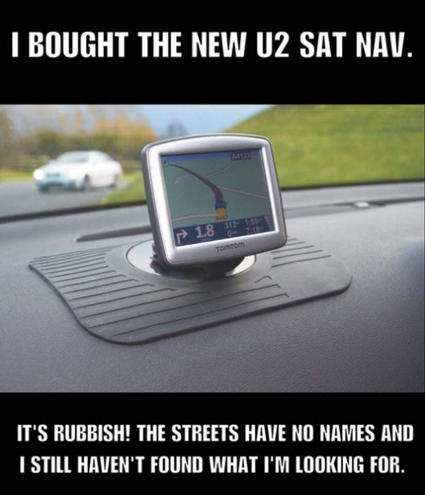
It’s been quite an adventure in my life since I last wrote an article for Rooted Life. So much has happened in such a short space of time. My eldest son has got married, my younger son has just been blessed with a new baby girl as we become grandparents again and I have been receiving continued treatment for a growth on my brain but have managed to return to work and things are looking like they’re going in the ‘right direction’.

The right direction…..such a funny phrase that. It’s a bit like the one that goes along these lines….”how are you?” …”oh I’m getting there” …..where might we ask is ‘there’??? Is it me who only ever ponders these thoughts? It’s a strange answer really isn't it? Getting there and right direction will be on my mind over the summer months as we embark upon various different journeys through the holidays. We have planned a family time away, whereby once again I will be calling upon my old friend…the satnav!

We have a love hate relationship the satnav and I. My wife cringes whenever we have to turn on the satnav as she knows that at some point in the journey satnav and I are going to have a conversation based on the fact that it’s telling me one thing and I want to do another.

I can almost guarantee that at a certain point on any given route it will tell me to go this way and I will think, no, this other road is quicker. And essentially that’s what it will come down to, my arrogance that I think I know best and can get us there quicker.

However, I must confess on more than one occasion, because I use a ‘live’ satnav system it has known what’s going on far up the road and I just haven’t seen it or got that information. And so I take ‘my’ way and low and behold we end up either stuck or taking twice as long to get somewhere as it would have, had I just surrendered and gone the way it was telling me in the first place.

Herein lies the problem I have and it can sometimes mirror my relationship with God. There are times when I must confess I like to think I know best. It comes from a spirit of wanting to be in control. My recent health scare has really taken me out of my comfort zone as it has been an issue where I cannot be in control but instead I am having to learn to do as I am told by Drs and specialists and even…the wife!
Surrender does not come naturally and for many of us, brings up fears. Fears of some other people dominating us or making us feel unvalued. A life of submission does not sound appealing or indeed enjoyable.
However, Jesus promised us time and again that in giving ourselves over to God we would find that we would have a better life. He said in the gospel of John from the Bible that “I have come that they may have life and have it to the full.”
He also said in the gospel of Matthew these words “For whoever wants to save their life will lose it, but whoever loses their life for me will find it.”

Perhaps you’re in a time you are slightly lost, or not sure which direction your life is headed in? Perhaps you fear that you’re not in control of your own life? Tired and exhausted you’ve come to the end of yourself. Can I encourage you to let go and let God!
I have found that the more I surrender and the more I follow His direction for my life the more peaceful I have become and the happier I have been. He sees far more than I can, He knows the pitfalls ahead in my life and nothing surprises Him. It brought me comfort in my recent highs and lows of life. Perhaps its time you lost your life of control and found life in all its fullness.
Now, as for me and our satnav I can only ask for prayer.

Paul Smith

PRAYER FOR FORGIVENESS

Jesus, I believe you are the son of God, that you died on the cross to rescue me from sin and death and to restore me to the Father. I choose now to turn from my sins, my self - centeredness, and every part of my life that does not please you.

I choose you. I give myself to you. I receive your forgiveness and ask you to take your rightful place in my life as my Lord and Saviour. Come and reign in my heart, fill me with your love and your life, and help me to become a person who is truly loving - a person like you. Restore me, Jesus. Live in me. Love through me. Thank you God. In Jesus name I Pray.
Amen.

ARE YOU ABLE TO SUPPORT US FINANCIALLY?

If you would like to make a gift to the church, or regularly support the work at WBC you can do this in several different ways:-
- There is an offering box by the exit door
- There are offering envelopes
- There is a card reader available to you, by the exit door
- You can also ask at the Church Office for giving information through your bank.
- Check out the ‘Giving’ tab on the website

A word from Rosedale bereavement support……….

Is there a correct way to grieve?

When faced with a bereavement for the first time, we might naturally look to what grief experts have to say on the subject.
There are many different theories about grief and how we might work through it. These different theories can be helpful to a point but can sometimes become a stick with which to beat ourselves. We can be made to feel that were not grieving ‘properly’ if we do not fit into the formula set out by a grief model. The truth is the only real expert on your grief, is YOU. Your grief is as unique to you, as is your relationship with the person who has died. We all have different personalities and ways of responding that are unique to us.
We can think of grief as a tangled ball of wool. Emotionally we can feel up and down, confused, angry, guilty, sad, relieved and as if we don’t know which way to turn. We can feel there is no way out and we can’t see the end.



It is important to remember that:
There is no right or wrong way to grieve.
There is no set time period for grief.
Others may suggest that you should be ‘over it’ by now. However, we can continue to grieve for our loved ones for the rest of our lives. Initially the grief is raw and all consuming, but usually over time this does ease. Though difficult, we do find a way to continue with life and the ‘new normal’ we are faced with. We will always think about them, love them and miss them, especially at certain times or on days when their absence is more deeply felt.
My experience is that over time grief becomes something that we learn to live alongside. I think of it as two parallel lines running alongside each other:

Everyday life _____________________________________________________
My grief __________________________________________________________

We do both at the same time.



In reality the two are not separate but intertwined (like the picture above.) Both pictures illustrate that we continue to grieve whilst also living life. We do not work through grief, come out the other side, then continue on as if nothing has happened.
In reality, we take the people we love with us, as we move forwards with life.
To find out more about joining one of Rosedale’s Bereavement Support Groups call 01379 640810 or visit our website rosedalefuneralhome.co.uk

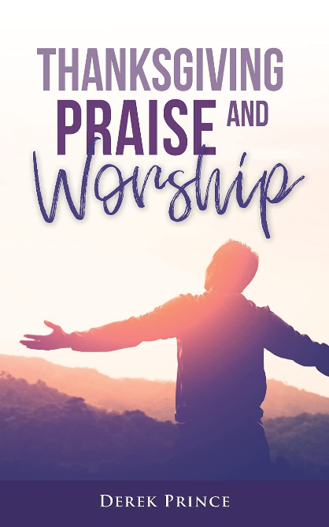
A good book to read

This small book comprising of only 53 pages is packed with Scriptures supporting the importance of incorporating thanksgiving, praise and worship into our prayer life in order to draw closer to God. Personally, I found this book revelationary and worth reading.

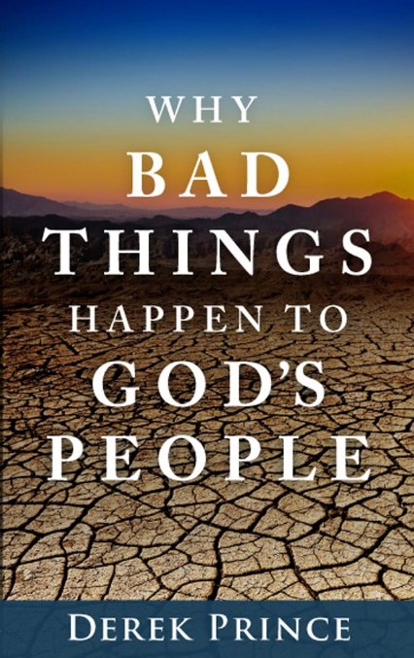
This book is very encouraging even though the title would suggest otherwise. Derek says he does not have all the answers but he does share truths from God’s Word how to come through the challenges of life. He teaches valuable lessons from the Book of Job.
As written on the back cover of this book he says there is one factor that set people of faith apart – hope.
There are other subjects covered in this book and one is the scriptural meaning of prosperity as opposed to the “Prosperity Gospel” version. Also the value of waiting as in the lives of Abraham and Moses. He says waiting deals with independence.
There is so much more in this book and a short review does not do it justice. Suffice to say I found it so interesting I decided to re-read it.
Kathleen Garlish


Do you miss parts of the church service because of a hearing loss, even though you have hearing aids?

Are you aware that the church has a very good hearing loop system for anyone using hearing aids that are fitted with a ‘T’ setting?

I have been using loop systems for several years and the system here is one of the best I have encountered.

Doug and the tech team have gone out of their way to make the loop work well, linking it with the headset microphone, room microphones and the worship team microphones.

I have tried it out and it works all around the hall no matter where you sit (although it is better not right against one of the walls).

If you haven’t got the ‘T’ setting on your hearing aids your audiologist should be able to sort it out in just a few minutes.

And – the loop setting can be found in many other places (such as banks, GP surgeries) wherever you see the sign:
DATES FOR JUNE

June 3rd POWER HOUR – 10.00a.m.
June 3rd Thrive@Roots – 3.15p.m.
June 4th Roots Community Café - 10.00a.m. – 1.00p.m.
June 5th Menscraft – 3.00p.m. – 5.00p.m.
June 6th Roots Community Café – 10.00a.m. – 1.00p.m.
June 6th Friday Night Youth – 6.30p.m.
June 8th Worship at 10.30a.m.
June 10th POWER HOUR – 10.00a.m.
June 10th Thrive@Roots – 3.15p.m.
June 11th Roots Community Café – 10.00a.m. – 1.00p.m.
June 12th Menscraft – 3.00p.m. – 5.00p.m.
June 13th Roots Community Café – 10.00a.m. – 1.00p.m.
June 15th Café Church – Breakfast served at 10.30a.m.
June 17th POWER HOUR – 10.00a.m.
June 17th Singing for Fun – 1.15p.m. – 2.30p.m.
June 17th Thrive@Roots – 3.15p.m.
June 18th Roots Community Café – 10.00a.m. – 1.00pm. – UNIFORM BANK OPEN
June 18th Ketts Books using premises -6.30p.m. – 8.30p.m.
June 19th Menscraft – 3.00p.m. – 5.00p.m.
June 20th Roots Community Café – 10.00a.m. – 1.00pm. – UNIFORM BANK OPEN
June 20th Friday Night Youth – 6.30p.m.
June 22nd Worship at 10.30a.m.
June 22nd Afternoon Tea and time with Alan & Megan Barker (BMS missionaries)
June 24th POWER HOUR – 10.00a.m.
June 24th Thrive@Roots – 3.15p.m.
June 24th Leadership Team Meeting – 7.00p.m.
June 25th Roots Community Café – 10.00a.m. – 1.00pm. – UNIFORM BANK OPEN
June 26th Menscraft – 3.00p.m. – 5.00p.m.
June 27th Roots Community Café – 10.00a.m. – 1.00pm. – UNIFORM BANK OPEN
June 28th Litter Pick Base for Greening Wymondham – a.m.
June 28th Quiz Night – 6.30p.m.
June 29th Worship at 10.30a.m.

DATES FOR JULY

July 1st POWER HOUR – 10.00a.m.
July 1st Singing for Fun – 1.15p.m. – 2.30p.m.
July 1st Thrive@Roots – 3.15p.m.
July 2nd Roots Community Café – 10.00am. – 1.00p.m.
July 3rd Menscraft – 3.00p.m. – 5.00p.m.
July 4th Roots Community Café – 10.00a.m. – 1.00p.m.
July 4th Friday Night Youth – 6.30p.m.
July 5th Meeting with local residents – 9.00a.m. – 10.30a.m.
July 6th Worship at 10.30a.m. including communion
July 8th POWER HOUR – 10.00a.m.
July 8th Thrive@Roots – 3.15p.m.
July 9th Roots Community Café – 10.00a.m. – 1.00p.m.
July 9th Rosedale monthly meeting – 10.00a.m.
July 10th Menscraft – 3.00pm. – 5.00p.m.
July 11th Roots Community Café – 10.00a.m. – 1.00p.m.
July 13th Worship at 10.30a.m.
July 13th Concert with St Mary’s Singers, Hemsby – 2.30p.m.
July 15th POWER HOUR – 10.00a.m.
July 15th Thrive@Roots – 3.15p.m.
July 15th Leadership Team Meeting – 7.00p.m.
July 16th Roots Community Café – 10.00a.m. – 1.00p.m.
July 17th Menscraft – 3.00p.m. – 5.00p.m.
July 17th Church Meeting – 7.30p.m.
July 18th Roots Community Café – 10.00a.m. – 1.00p.m.
July 18th Friday Night Youth – 6.30p.m.
July 21st BREAKING GROUND
July 27th Worship at 10.30a.m.

………………………………………………..

BURNING COALS
Proverbs 25:21–22 reads "If your enemy is hungry, give him food to eat; if he is thirsty, give him water to drink. In doing this, you will heap burning coals on his head, and the Lord will reward you." These verses unfortunately always conjured up an unpleasant image for me, I have a very literal mind.

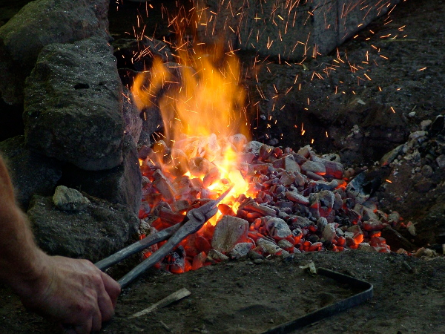
But the verse is not about actually burning the person. (Yeah, I knew that really...😟... errm...what a relief.) Studying it further, I found out that in Egypt there had been a custom to carry a pan of burning coals on one's head as a sign of repentance. So the phrase is intended as a metaphor for making your enemy feel a sense of shame and guilt for their actions, possibly leading them to repentance or at least remorse. The Proverb also promises that God will reward those who do good to their enemies, regardless of the person's response.

I pictured a blacksmith at work, heaping burning coals on to a piece of metal. It is thrust into the middle of the hot coals, and then more are heaped on top of it. The temperature is carefully monitored, to ensure that the metal reaches the right temperature and malleability for forging. Then the blacksmith can shape the metal into whatever he wishes to make.

It made me think about the hymn "Refiner's Fire", which contains the verses :

Purify my heart, let me be as gold and precious silver,
Purify my heart, let me be as gold; pure gold
Refiner's fire, my heart's one desire
Is to be holy, set apart for you Lord
I choose to be holy, set apart for You, my Master
Ready to do Your will.

God is always at work in everyone's life, to bring us closer to Him even in the midst of hostility. Personally, I have had to repent many times of reacting badly or holding a grudge. But from this Proverb I can see a way forward, and pray that I will increase in my ability to love my enemies just as the Lord loves both them and me.

Tracey Westlake

Unused, boxed dinner set



If you like this dinner set please speak to Jan or Doug Hodges. Good quality and unused

SMILING
Smiling is infectious
You catch it like the flu
When someone smiled at me today.
I started smiling too.

I passed around the corner and
Someone saw me grin
When he smiled I realised
I’d passed it on to him.

I thought about that smile
Then I realised it worth
A single smile
Just like mine,
Could travel round the Earth.
So, if you feel a smile begin,
Don’t leave it undetected
Let’s start an epidemic quick,
And get the world infected!

Well done Eco Church for the nesting box


During the ‘Old and New sale’ I sat by the open door that leads from the lounge into the church garden. Whilst there I noticed that adult Great Tits were flying to the nesting box that is just by the door where the ramp leads into the garden.
They were not going into the box but were sitting on top and calling, then flying off.
Then a little head popped out of the box, looked around, and disappeared back inside.
then a small Great tit squeezed out of the hole – and off it flew.
Over the next 15-20 minutes 3 more baby Great Tits did the same.
So I saw the fledging of 4 baby Great Tits – something I have never seen before.
It shows how much goes on in the garden – that we might not always notice.
Just sitting, quietly, waiting and watching what God has created. Beautiful and remarkable!
I shall sit and watch and wait again – and I encourage you to try it.

Graham Warner
OLD AND NEW SALE
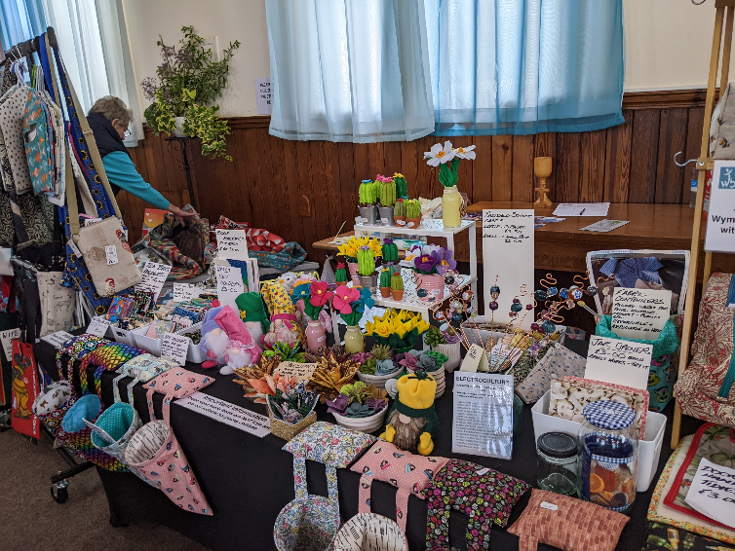
May 24th was a busy day at WBC. The church was full of tables showing a variety of crafts contributed by a number of different people – folk from the church and from outside the church. The Youth Rooms were filled with pre-loved items and the church lounge was set for tea/coffee and cake which was served from the main servery. We were disappointed with the footfall but nevertheless we OLD AND NEW SALmanaged to raise over £700 for the Building Project.
Jo’s Craft items

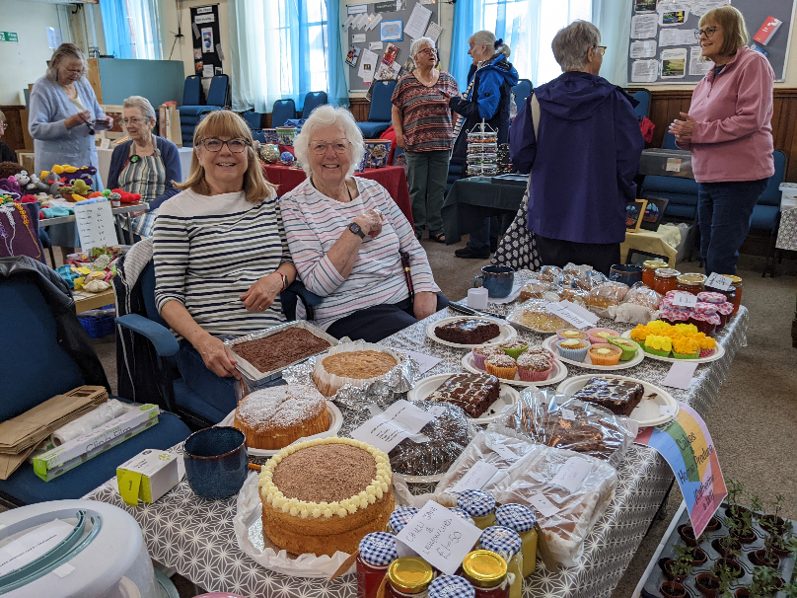

W.I. Cake stall

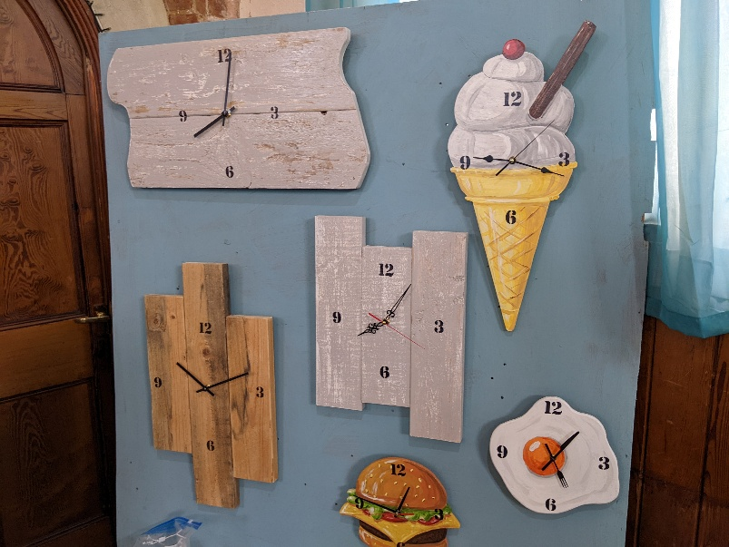

Vic’s clocks

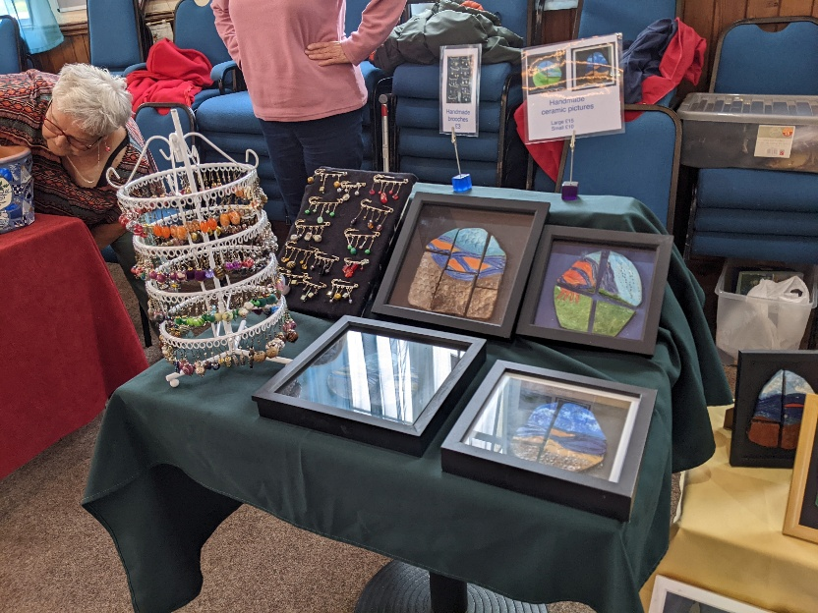

Jewellery and glass art

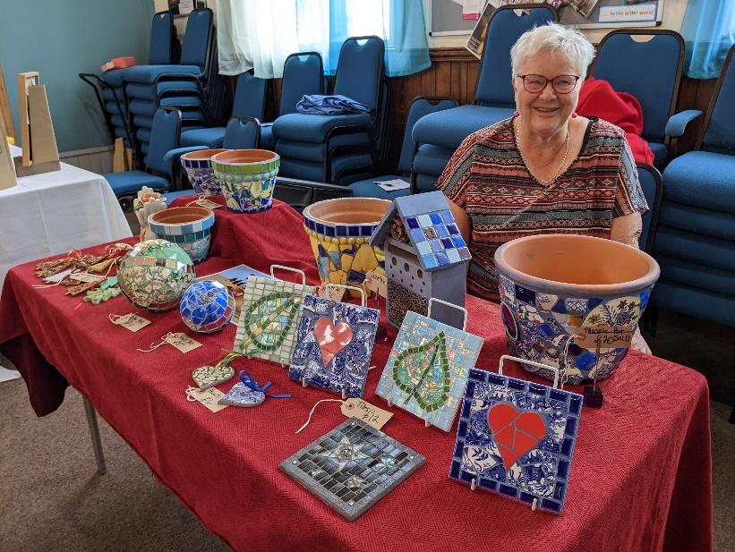

Vera’s mosaics

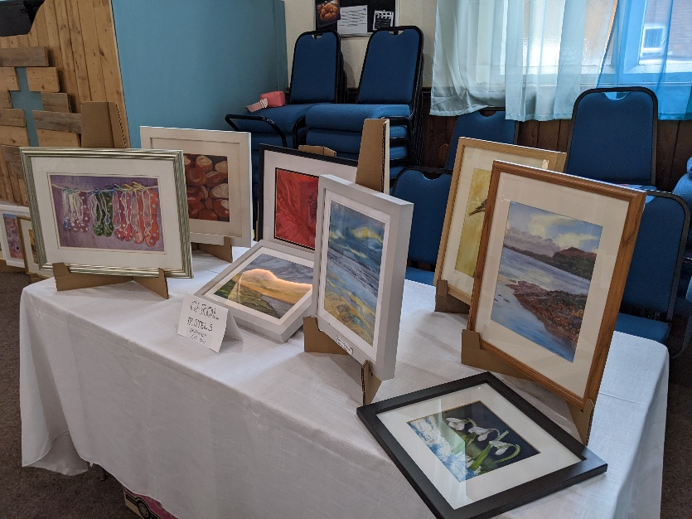

Carol’s paintings

Thank You to everyone who contributed to the event and those who came along in support.



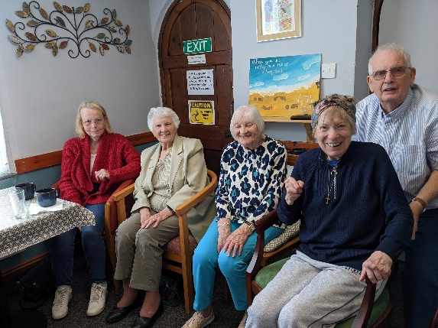
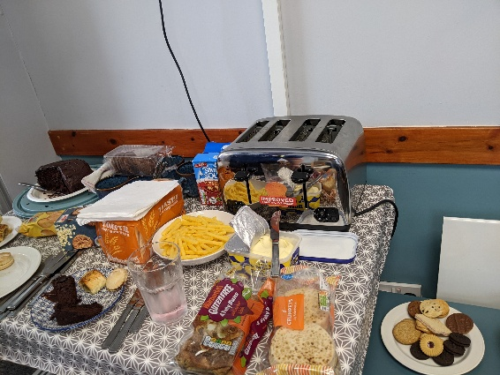
LAST MEETING OF HOME AND HOME FOR A WHILE
Home from Home has met every Thursday since last October and this year we have welcomed a number of new visitors. Our time is spent enjoying one another’s company, playing simple card games, dominoes, Jenga, painting stones, doing word puzzles, reading the paper and doing jigsaw puzzles. As well as these activities there always has to be tea/coffee, cake, toast and nibbles. We have continued to meet throughout May rather than stopping at Easter as a number of our visitors asked us to carry on, proving to us that the need for company is greater than the need for warmth. There is always a lot of fun and laughter and also sharing time with the men who meet with the Menscraft group.

During the summer we are planning to get together on a few Thursday afternoons, possibly in the garden (weather permitting) as those who come along need company and the team who lead this group are happy to provide this. Please pray for the folk for whom this group has meant a lot. We are hoping that even during the building work there may be a way that we can keep in touch and perhaps meet up somewhere.

The last puzzle we did

Home from Home Team

BRAIN TEASERS
What has a head and tail but no body?
What has many keys but never opens a single lock?
What belongs to you but others use it more than you do?
What has one eye but can’t see?

